CS-570 INTRODUCTION TO HUMAN-COMPUTER INTERACTION  
SPRING 2020 | PROFESSOR LEWIS-WILLIAMS

Assignment 7: Novel Interfaces

ARSHAD HABIB, RIZA HASSAN, JOON LIM

UW STUDENT JOB PORTAL

**Introduction**

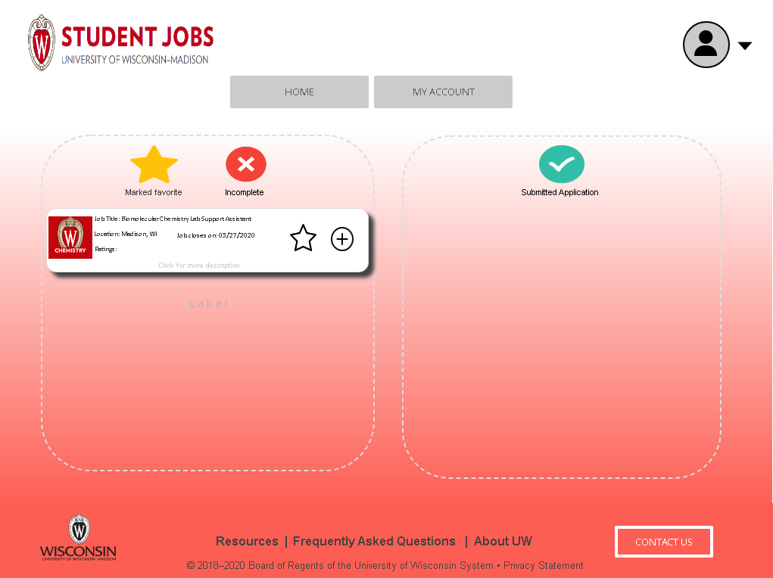

The University of Wisconsin-Madison has extensive career opportunities for those who are seeking one. Many departments recruit students to join their workforce since students offer the skills and talents that they require. Because of that, the UW-Madison Office of Financial Aid provided a job search platform for students.

The job search platform is known as the UW-Madison Job Portal. A student shall go to the UW-Madison career website and then visit the job portal to search for jobs they are interested in.

Our project develops a more user-friendly and organized UW-Madison Job Portal.

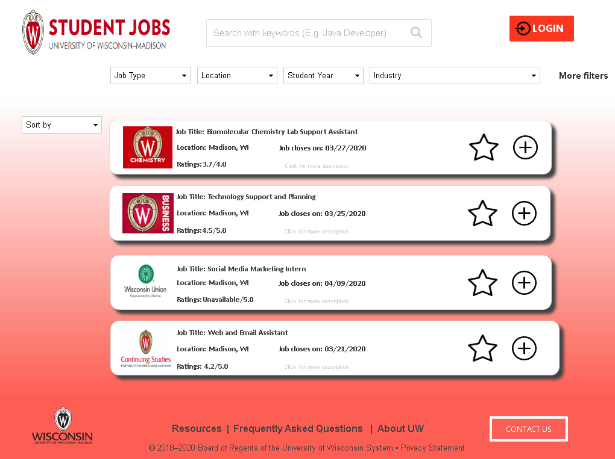

**Image 1 shows the Main Page**

The prototype offers more organized filters and a sort-by feature. All filters are centralized at the top of the page to help users find their jobs easily. In addition, it follows the modern web design trend that enhances User Interaction and User Experience. For example, the Search bar has automated searchability and the jobs are listed on a job card. A user can read more about the job by clicking on the individual job card.

**Image 2 shows the Account Page**

The prototype also has an Account Page. This page lists jobs that are marked as favorite and jobs that have been submitted by the user. It gives the user the freedom to edit or submit their jobs from a single page.

In addition to these pages, users will be redirected to other pages such as the Application page and Profile page. These pages allow the user to apply for a job and edit their personal information easily.

**PROCESS UNDERSTANDING**

The existing interface has some key flaws that if improved will allow us to create better usability of our interface and improve the overall design of our system.

First, we would like to talk about improving the aesthetic design. From our reviewers, we would fix the combo box on the submit application page to allow the user to see all options without the “preview application” button covering the options. Additionally, we were having inconsistencies in the design such as color, size of elements, text placement, and overall element placement. The color gradient on the home page is not very appealing, the size of elements such as the (star, add, etc) are larger in size than necessary, and the job tabs on the home page aren’t aligned well. The text in the job tabs is not aligned, as well as the images of the departmental logos. Based on the above, we would focus on consistent color for the background to create contrast rather than gradient, improve logo, text and symbol sizes, and overall situational arrangement of the job tabs. The goal of the new design would be to make everything feel in unison with the text and different elements fit appropriately in place.

Second, the prototype is lacking the ability to help users to recognize, diagnose, and recover from errors. When a user tries saving an incomplete job application, the prototype crashes and the warning information is unreadable.

**Image 3 shows the Application Submission page**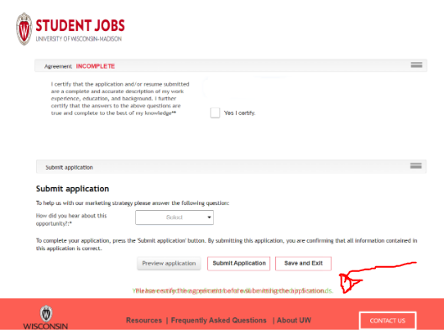

Third, our prototype does not satisfy the heuristic of recognition rather than recall. A user was unsure how the Account page relates to the main screen. This is because, after the user logs in, they are automatically redirected to the Account Page without any information on how to go to the Main Page. This issue adds more unnecessary detail to the user’s memory load because they have to figure out the steps themselves.

**PROCESS UNDERSTANDING**

All in all, we would like to implement the Job Portal on a Voice Assistant medium. As a starter, we would implement it on Siri on Apple devices. The reasons we chose the Voice Assistant are to reduce the need for aesthetic design, to help the user recognize errors easily, and to reduce the user’s memory load while using the domain.

The domain will use Siri’s design and interaction features. Since iPhone users are familiar with Siri, they might be used to its design and features. Our domain will utilize Siri’s simple visual design as shown in the image below. Users can also access our domain without the visual element. For example, they can use a Home Assistant device that does not have a screen.

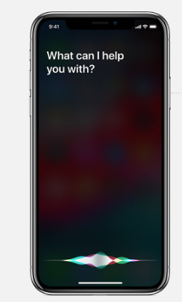

**Image 4 shows Siri on an iPhone**

Next, users will be able to recognize and recover from errors with the help of the efficient Error Handler and Prevention in Siri’s API. For example, the user will be notified by Siri if the domain crashes. With simple error messages from Siri, the user will be able to identify the issue more easily.

Using the Voice Assistant technology will reduce the user’s memory load. This is because a Voice Assistant like Siri is not overloaded with unnecessary visual elements and information. In addition, the AI algorithm in Siri will help a user complete their request.

**IDEATION (BRAINSTORMING)**

When the user sets up their voice assistant to access UW Job Portal when searching for a job, it would automatically sign in the user with a set account. Users can ask an assistant to take them to the web portal or continue their process using a voice assistant.

Notification will be a big part of voice assistant. Whenever there is a new message from the employer or website, the voice assistant will alert the user right away. Another notification can be assigned by the user. For example, if the user sets up the key words or the job category that the user is interested in, whenever there’s a new job listed that fits the criteria, the user will be alerted. Also, if the jobs that users have selected as favorite before but didn’t actually apply yet are taken down from the website, the voice assistant will alert the user that the job is no longer available. In fact, the assistant will alert the user if the user sets it up to notify the user when the available spots are nearly gone.

Users can also search for new jobs using Siri. Although there are many limitations due to limited visibility, AI will enable users to search for a specific job. For example, asking Siri for a library job will be difficult since there are numerous jobs related to libraries. However, Siri will be able to show specific jobs when the user asks for the exact location and specific type of job or job title. If the users want to know more about the job, they can simply ask Siri to direct them to a page with detailed information.

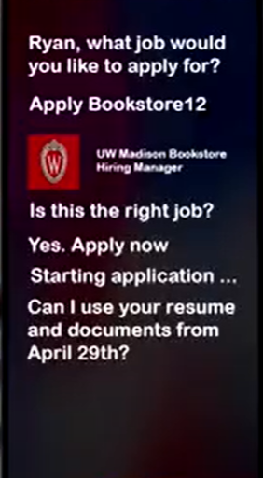 **Image 5 shows sample voice assistant when searching and applying using voice assistant**

Users can also use Siri to apply for a job. After finding the job that the user is interested in, Siri will ask the users whether they want to apply for this job. If the user account lacks information that is required when applying for a job, voice assistants will tell which parts of information is missing. This can be much more convenient than using visuals as the AI assistant will point out what’s missing. If the missing information can be filled or agreed with voice, Siri will just ask the user for the information. If it must be typed, Siri will guide the user to the page. For example, if the user’s account has a resume that’s already been uploaded, the voice assistant will simply ask the user if he wants to use the resume uploaded on a specific date.

**PROTOTYPING**

In this section, describe your development of your scenario, including the personas and vignettes your team developed, the final script and storyboards of your scenario, and the creation process.

We developed the scenarios based on potential user personas such as students from different majors and career goals with substantial to very limited technology experience and focused on potential environments that the user may be interacting in their college. We were trying to make our innovative technology inclusive and generalizable to all student backgrounds. Creating a user persona started with peer evaluation research and general understanding of potential student users. Primary process in the creation process was to divide the script into scenes, and use the scenes to write a comprehensive description of the story for each story frame. Users are the students as specified since we are utilizing the student job portal. The primary objective or the goal of the user is to apply for the job using the Voice Assistant tool on any compatible device.

First persona is Ryan. As a college junior who is a non-technology major, Ryan isn’t technology affluent, but uses his phone frequently. He wants a job at his college and wants access through an easy and understandable platform or interface, his mobile phone.

The second persona is Sam. He is a college freshman who is just entering the university. Coming into a university is very expensive and requires expenses which causes him to be drowning in debt. He wants a job to cover his burdening expenses. Surprisingly, at his visit to the bookstore, he stops by the job advertisement board. He finds a new platform that is quick and easy to apply for jobs, just from his phone. He leaves very happy.

The final persona is Jack. Jack is an athlete who recently got injured playing soccer at the university. Due to his injury, he incurred a lot of expenses. Though he is temporarily disabled, he needs a job. He wants a job at his college and wants access through a hands-free and easy platform for applying. Luckily, the new student job platform by university allows him to do so.

**SCENARIO 1**





**PROTOTYPING**

**SCENARIO 2**



**PROTOTYPING**

**SCENARIO 3**



